**Project Design Phase-II**

**Technology Stack (Architecture & Stack)**

|  |  |
| --- | --- |
| Date | 03 October 2023 |
| Team ID | NM2023TMID05023 |
| Project Name | A COMPARATIVE STUDY OF TOP GLOBAL UNIVERSITIES IN DATA ANALYTICS |
| Maximum Marks | 4 Marks |

**Technical Architecture:**

The Deliverable shall include the architectural diagram as below and the information as per the table1 & table 2

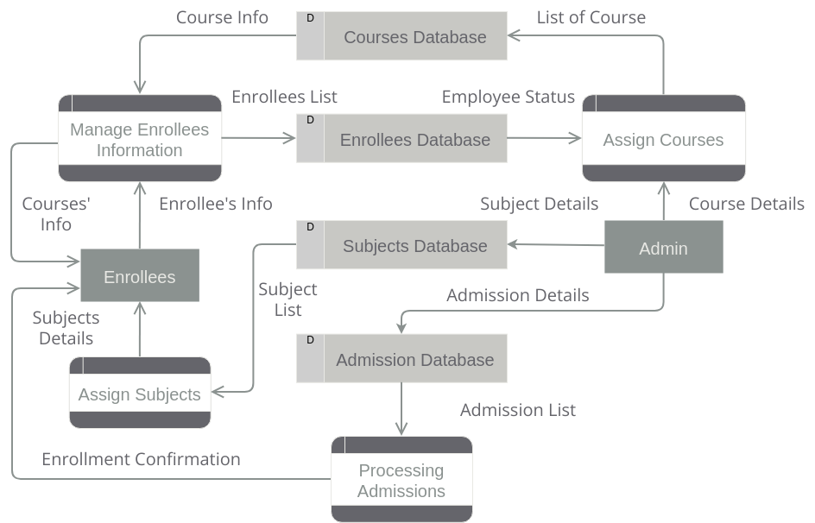

**Table-1 : Components & Technologies:**

|  |  |  |  |
| --- | --- | --- | --- |
| **S.No** | **Component** | **Description** | **Technology** |
| 1. | Academic Departments | Top universities typically have a wide range of academic departments covering various fields of study, including sciences, humanities, social sciences, engineering, and more | HTML, CSS |
| 2. | Faculty | World-class universities have distinguished faculty members who are experts in their disciplines. | JavaScript / Angular Js |
| 3. | Research fecilities | Top universities invest heavily in research facilities, including state-of-the-art laboratories, libraries, and digital resources. These facilities support cutting-edge research and innovation. | Java / Python |
| 4. | Student body | These universities attract a diverse and talented student body from around the world. The student population often includes individuals from different cultures and backgrounds, contributing to a rich learning environment. | / Angular Js / React Js etc. |
| 5. | Global reputation | Top universities are recognized internationally for their academic excellence, often ranked highly in global university rankings. | MySQL, NoSQL |
| 6. | Resource and funding | These institutions typically have substantial financial resources, including endowments and grants, which support academic programs, research, and student scholarships. | CSS, JavaScript / Angular Js |
| 7. | Quality of education | Top universities offer high-quality education, with a focus on rigorous academic standards, innovative teaching methods, and challenging coursework. | Angular Js / React Js etc. |
| 8. | Global perspective | Many top universities emphasize a global perspective in their curriculum and encourage students. | Angular Js / React Js etc. |

**Table-2: Application Characteristics:**

|  |  |  |  |
| --- | --- | --- | --- |
| **S.No** | **Characteristics** | **Description** | **Technology** |
| 1. | Academic excellence | Top comparative universities are known for their commitment to academic excellence. They have high standards for faculty, research, and teaching, and they often attract some of the brightest and most accomplished students from around the world. | HTML, CSS |
| 2. | World-Renowned Faculty | These universities typically have faculty members who are leaders in their respective fields. They often conduct groundbreaking research and contribute significantly to the advancement of knowledge. | CSS, JavaScript / Angular Js |
| 3. | Research Opportunities | Top comparative universities offer extensive research opportunities for both undergraduate and graduate students. They have state-of-the-art facilities and resources that support cutting-edge research in a wide range of disciplines. | Angular Js / React Js etc. |
| 4. | Strong Alumni Network | Graduates of these universities often join a powerful alumni network that can provide valuable connections and opportunities in their future careers. | Java / Python |
| 5. | Interdisciplinary Approach | Many top universities encourage interdisciplinary learning and research. This allows students and faculty to collaborate across different fields and gain a broader perspective on complex issues. | MySQL, NoSQL |